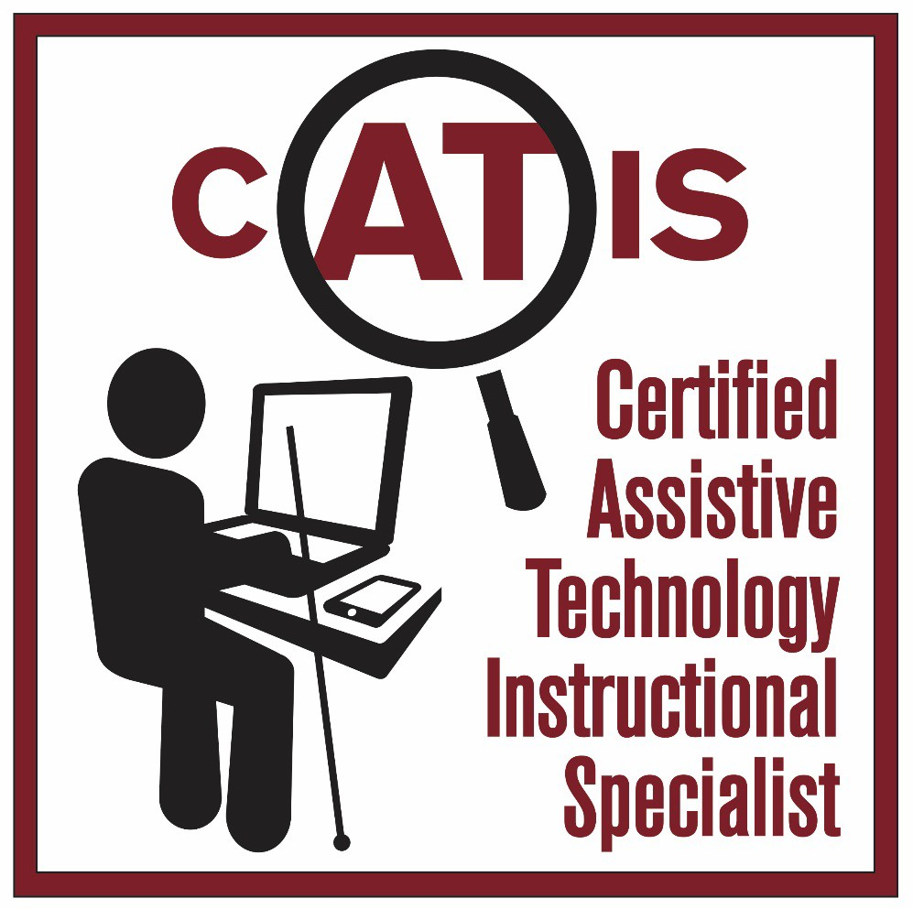

The CATIS logo is an outline of a person sitting at a desk and on the desk is a computer and smart phone with a cane leaning against the desk. In the word CATIS at the top of the logo the letters “AT”, circled by a magnifier, are larger than the other letters. The logo is meant to signify that CATIS serve individuals that are blind and visually impaired. The name is spelled out down the side of the logo.

# “CATIS”

**A QUICK REVIEW**

**“CATIS”**

Certified Assistive Technology Instructional Specialist

for Individuals who are Blind or have Low Vision

**A highly trained expert who specializes in working with individuals who are blind, have low vision or who have functional visual limitations and empowers them to achieve their life goals for education, employment, avocation and independence through the use of assistive technology.**

# “CATIS”

Must have knowledge in 4 areas:

* **Assessment**
* **Instruction**
* **Configuration**
* **Exploration**

# “CATIS”

**Engage in a comprehensive approach to vision rehabilitation addressing visual, physical, cognitive, and psycho-social aspects related to training and integration of existing and emerging technologies. Methods and strategies include the use of visual techniques, non-visual techniques (auditory and tactual), strategies and problem-solving skills through the use of various Assistive Technology devices and solutions**

To be effective in the instruction of Assistive Technology a professional must

* **Assess the individuals needs and abilities in order to guide in the selection of the appropriate technologies for meeting the individuals goals,**
* **Understand different learning styles, how that differs based on visual acuity and the most effective teaching techniques for each style**

# “CATIS”

**Are Bound by a Strong Code of Ethics**

**“CATIS”**

**Recertify every 2 years to ensure that they remain current in the field**

When an Employer hires a CATIS they know that they are hiring a vision impairment professional that:

* **Represents best practices based on a national standard in providing Assistive Technology assessment and instruction**
* **Through their knowledge and skill will achieve the best possible outcomes for the clients that the agency serves**

# “CATIS”

**AN UPDATE**

When ACVREP began the development of the CATIS certification there were no university programs providing Master’s or graduate level Certificate programs in ATBVI

## “BUILD IT AND HE WILL COME”

Movie Quote from Field of Dreams

## There are now 4 University

**Programs for ATBVI**

Master’s and Graduate Certificate Programs:

* + **Northern Illinois University**
  + **Western Michigan University**
  + **U-Mass Boston**
  + **North Carolina Central University**
* **In 2016 when the CATIS certification launched Northern Illinois University was awarded a federal grant for a Master’s and a graduate level Certificate program in ATBVI including scholarship funding for students**
* **They have already graduated 2 cohorts and are currently admitting students**

Western Michigan University is currently admitting their 1st cohort

U-Mass Boston is expecting to admit their 1st cohort in the fall of 2019

North Carolina Central University is expecting to admit their 1st cohort in the fall of 2019

Additionally, North Carolina University (NCCU) is offering an online workshop to assist those currently working in ATBVI who wish to apply for CATIS through Category 2 to meet the educational requirements for Assessment, Instruction and ATBVI

**CATIS is going International:**

* + **There are currently 6 applicants from Ireland taking the NCCU workshop in order to qualify for CATIS Eligibility in Category 2**
  + **Discussions have been held with ATBVI personnel in Australia**
* **182 Applications for Eligibility since CATIS was launched mid-year 2016**
* **127 Have met the Eligibility requirements**
* **96 CATIS are certified (**as of 3-19-19)



3/19/2019

Contact:

Kathleen Zeider

President

ACVREP

[kzeider@acvrep.org](mailto:kzeider@acvrep.org)

Phone: 520 887 6816 x 3