**Carlos R. Servan, J.D**

**President, National Council of State Agencies for the Blind**

**4600 Valley Road**

**Ste. 100**

**Lincoln NE 68510**

**(402) 471-8104**

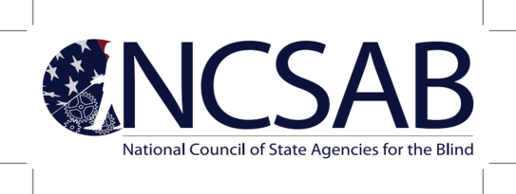

**Carlos Servan, President ▪ Dr. Cassondra Williams-Stokes, President-Elect ▪ Tracy Brigham, Treasurer ▪ Shirley Robinson, Secretary**

July 26, 2023

U.S. Department of Education  
400 Maryland Avenue, SW  
Washington, D.C. 20202

RE DCL-23-02

Dear Assistant Secretary Wright-Gallo and Deputy Commissioner Dobak,

I am writing on behalf of the National Council of State Agencies for The Blind (NCSAB). NCSAB represents state vocational rehabilitation agencies that provide services to persons who are blind or visually impaired. We are writing regarding DCL-23-02, which changed the interpretation of “recipient” for purposes of determining satisfaction of the carryover requirement of section 19(b) of the Rehabilitation Act of 1973. We believe this new interpretation of section 19(b) will have an especially negative impact on Blind agencies. The new interpretation will reduce the expenditure of federal VR funds since many Blind agencies will be unable to carryover federal funds due to the inability of larger General agencies to satisfy their match requirement. While there may be instances where the new interpretation will result in a Blind agency that did not meet its match to be able to carryover funds, we believe This will be the less common occurrence. The interpretation will also negatively impact on the ability of Blind agencies to comply with the requirement to reserve and spend at least 15 percent of the VR grant on the provision of Pre-Employment Transition Services. This is because the inability to carryover VR funds means the 15 percent Pre-ETS reserve must be entirely spent in the first year of the period of performance. Coordinating the statewide match will also place additional administrative burdens on both Blind and General agencies.

We also strongly believe that public input should have been sought prior to the implementation of such a significant interpretation of the Rehab Act. The Dear Colleague Letter states, “by requiring the State as a whole, not each VR agency in the State, to satisfy the match requirement for the VR program, the benefits and impact of the VR program are likely to be greater.” We believe that VR agencies should have been allowed to offer their input and comments, which would have better informed RSA as to whether or not it would be true that the benefits and impact of the VR program are likely to be greater.” It would also have been consistent with the policy of the Biden Administration to encourage greater community engagement.

It is our request that we schedule a meeting to discuss the impact of DCL-23-02 on blind agencies. Again, we also request that our input be sought prior to the implementation of such significant program changes.

Respectfully,

Carlos R. Servan

Carlos R. Servan, JD

President

National Council of State Agencies for the Blind