**Bill Robinson**

**State Director**

**Bureau of Services for Blind Persons**

**702. W. Kalamazoo**

**PO Box 30652**

**Lansing, MI 48915**

**517-335-4265**

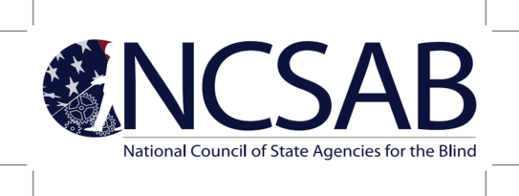

**Bill Robinson, President ▪ Dr. Bernice Davis, President-Elect ▪ Tracy Brigham, Treasurer ▪ Cassondra Williams-Stokes, DM, Secretary**

January 13, 2021

Dear NCSAB Membership:

The mission of the National Council of State Agencies for the Blind (NCSAB) is to promote through advocacy, coordination, and education the delivery of specialized services that enable individuals who are blind and visually impaired to achieve personal and vocational independence.

In furtherance of NCSAB’s mission, the Executive Committee drafted a Statement on Racial Equity. The Statement on Racial Equity was presented at the business meeting of the 2020 Winter Virtual Conference. Based on feedback to date and the Executive Committee’s approval, I am pleased to share with you NCSAB’s Statement on Racial Equity.

**NCSAB’s Statement on Racial Equity**

NCSAB, as a membership organization, has a responsibility to lead sustainable systemic change throughout the national public vocational rehabilitation program that eliminates racial inequities in informed choice, access, service delivery and outcomes.

The Workforce Innovation and Opportunity Act (WIOA) places a greater emphasis on outcomes and performance including preparing students with a disability for the 21st Century economy. We believe achieving racial equity is essential in order to fully achieve the vision of WIOA and removing all barriers to full employment of job seekers with disabilities throughout our nation, supporting businesses in diversifying their workforce and preparing all students for post-secondary outcomes.

As leaders in public vocational rehabilitation, we are committed to ensuring racial equity in the programs we administer to achieve long term, sustainable change. Meeting the needs of our communities of color who experience disability will improve our success in increasing the outcomes for all whom we serve.

Approved for distribution by the NCSAB Executive Committee (<http://www.ncsab.org/Home/ExecCommittee>)

January 5, 2021